
TIP: To open a student record, right-click and select See in New Tab.
By opening in a new tab, you can easily close the window when finished and return to your class roster.

Use this resource to view your Course Section Roster.

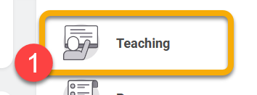
Instructions
- Log into Workday. From either the top-left menu or the right-hand menu, click “Teaching”. This is the hub for all your instruction-related tasks.
- Click “View Course Section Roster”.
- Click the Course Section field and select “My Assigned Course Sections”. Select a course section.
- Click “OK”.
- Review the Course Section Roster.
.

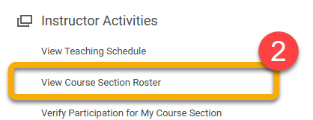

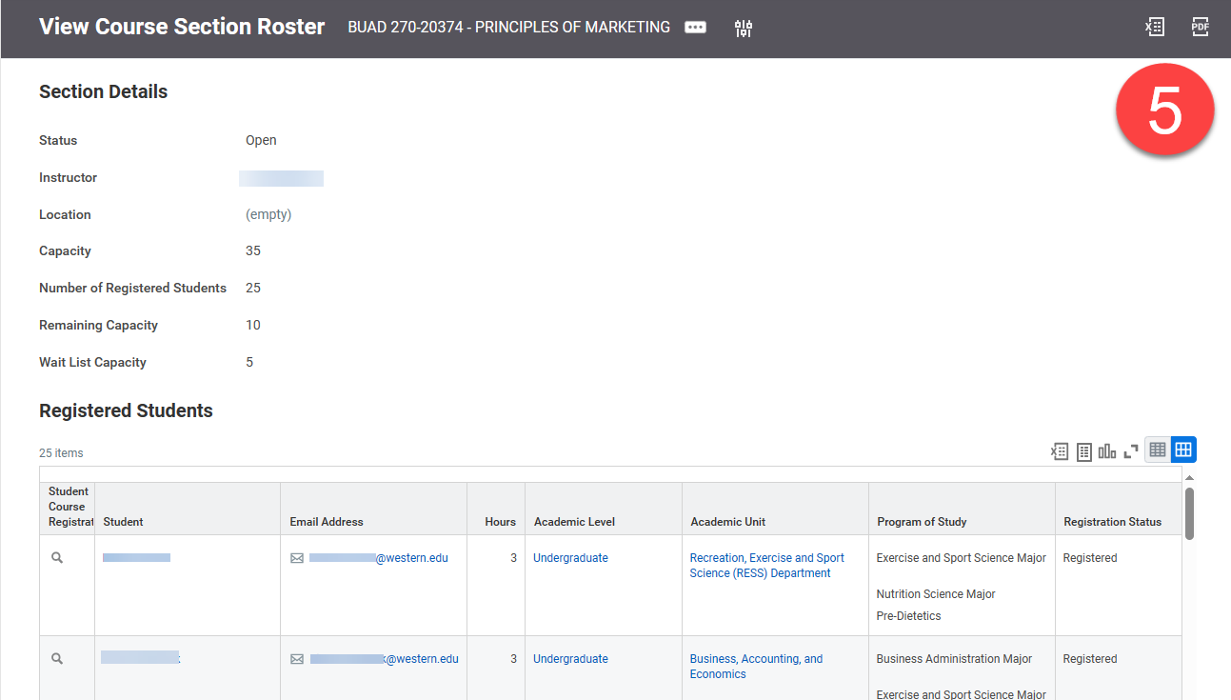
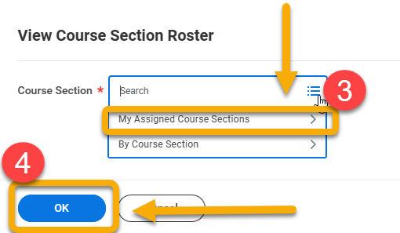

INSTRUCTIONS
- Log into Workday. Click “Teaching” from the top-left menu or the right-hand menu. This is the hub for all your instruction-related tasks.

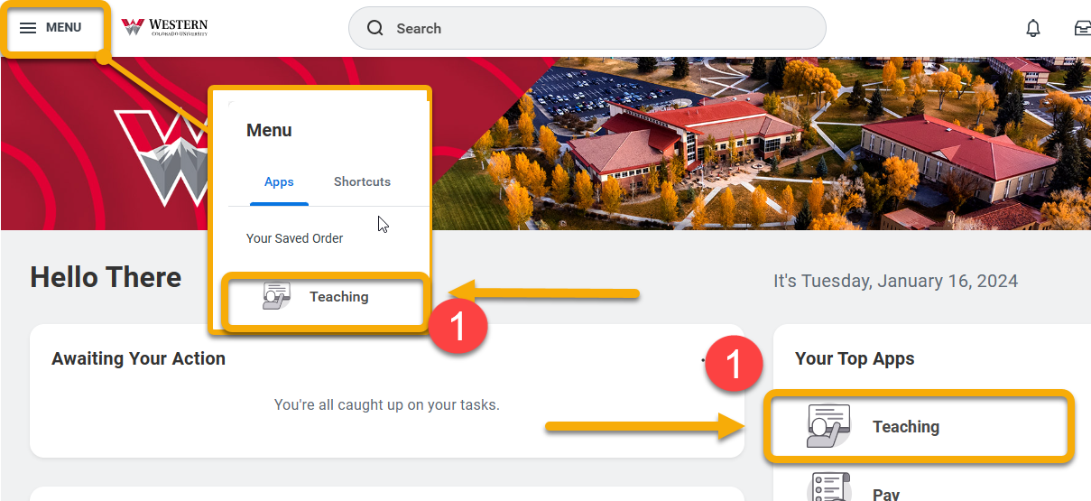

- Click “View Course Section Roster”.
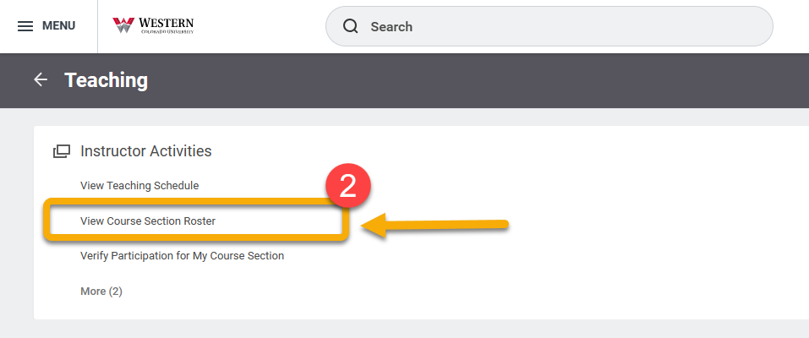
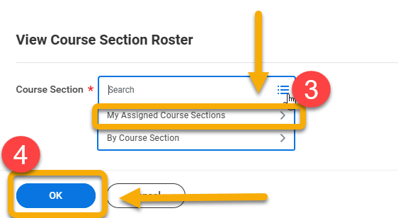
- Click the Course Section field and select “My Assigned Course Sections”. Select a course section.

- Click “OK”.

- Review the Course Section Roster. See below for highlights.
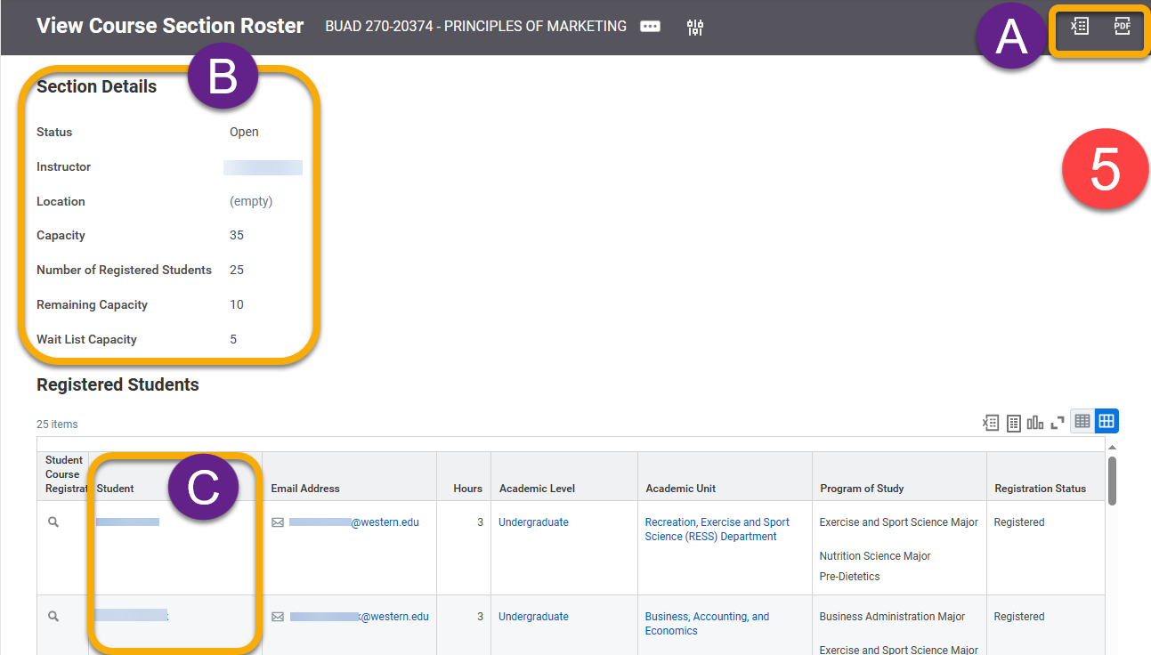
- Export and download the roster in PDF or excel.
- Course Section details

- List of registered students. To view the students’ record, click the student name.

TIP: To open a student record, right-click and select See in New Tab. By opening in a new tab, you can easily close the window when finished and return to your class roster.

- To view or edit a student record from your roster, click the Related Actions button This appears when the cursor hovers next to the student name. From this window, you can add notes, look-up contact or academic information, and apply/remove a hold.

